
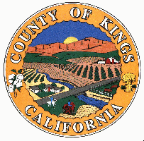


.
- At least 18 years of age.
- In good physical and mental health.
- An understanding of the safety, permanence, and well-being needs of children and non-minor dependents who have been victims of child abuse and neglect, and a capacity and willingness to meet those needs, including the need for protection, and a willingness to make use of support resources offered by the agency, or a support structure in place, or both.
- An understanding of children’s or non-minor dependents’ needs and development, effective parenting skills or knowledge about parenting, and a capacity to act as a reasonable and prudent parent in day-to-day decision making.
- An understanding of his or her role as a Resource Family and a capacity to work cooperatively with the County and other service providers in implementing a child’s or non-minor dependent’s case plan.
- The financial ability within the household to ensure the stability and financial security of the family.
- An ability and willingness to maintain the least restrictive and most family-like environment that serves the needs of a child or non-minor dependent.
- Demonstrate an understanding of the rights of children or non-minor dependents in care and his or her responsibility to safeguard those rights.
- Knowledge and willingness to prepare a child for adulthood or to prepare a non-minor dependent for the transition to independent living.
.
To Request an RFA Application contact:
Sylvia Zendejas-Social Worker
Melissa Perez-Social Worker
Julissa Orozco- Social Worker
Charlene Lord-Social Work Supervisor
San Benito County Human Services Agency

Phone: (831)636-4382
Fax: (831) 637-5510

1111 San Felipe Rd., Suite 205
Hollister, CA 95023

Or email:

rfa@cosb.us

Caregiver Qualifications

It’s not a job; it is a commitment to our community’s children.
san benito County Resource Family Approval (RFA) Program


- Orientation
- 12 hour RFA
Pre-Approval Training
- CPR/First Aid Certified
- Additional training as
needed
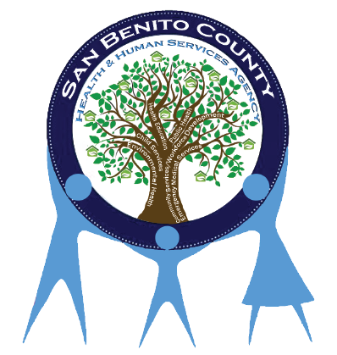

What is the Resource Family Approval Process?

- One application.
- One background check
- Combined Home environment and permanency assessments.
- Pre-approval and post-approval training for all families.

Pre-approval training

Post-approval training

- 8 hours per year
- Current CPR/First Aid

Training is provided free of charge.

What is a Resource Family Approval?

- An individual, couple, or family who wants to provide care to a related or unrelated child who is under the jurisdiction of the juvenile court, or otherwise in the care of a county child welfare agency or probation department.
- A Resource Family has successfully met approval standards which include home and ground inspection, risk assessment, background clearances, training and a permanency assessment as established in the Resource Family Written Directives.
- Upon approval, a Resource Family is considered to be approved for providing foster care, becoming a legal guardian or adopting a child without going through additional processes.

What is a Resource Family?

RFA is a unified, family friendly and child-centered resource family approval process that replaces the existing multiple processes, eliminates duplication, and increases approval standards by incorporating a comprehensive family evaluation of all families that want to foster, adopt, or provide legal guardianship to a child.

